
The Forum of Women in the Environmental Field Presents:
Family Friendly event: Fossil Hunting!
Wednesday, July 22nd 2009, 5:30pm-7pm
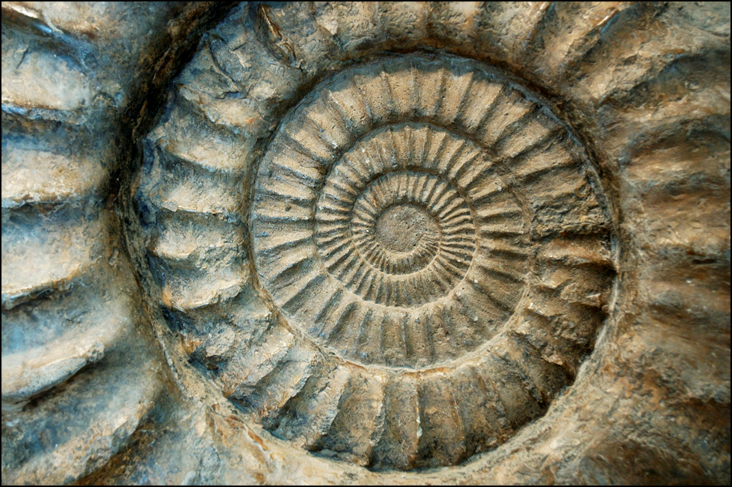
Join FWEF at Lilydale Regional Park to hunt for fossils. About 450 millions years ago, much of Minnesota was under 100-150 feet of water. Come see fossilized remains of this ancient ocean. The "brickyards" is one of the best places to look for these fossils in the Twin Cities. Learn about the geological and cultural history of this unique area of St. Paul. A local meal will be provided; purchased from Trotter’s Café!
Special notes: Wear good shoes or boots (no sandals please). This event is appropriate for adults and kids over age 5. Bathroom facilities are a short car ride away, if needed.
Location: 950 Lilydale Road, St Paul, MN 55118
RSVP: by Monday, July 20th, 2009
Cost: is $18 ($12 for members, $10 for students/additional guests)
Register online at www.fwef.org

FWEF Event FWEF Event FWEF Event FWEF Event FWEF Event
Fossil Hunting Fossil Hunting Fossil Hunting Fossil Hunting Fossil Hunting
July 22nd-evening July 22nd-evening July 22nd-evening July 22nd-evening July 22nd-evening
Register: fwef.org Register: fwef.org Register: fwef.org Register: fwef.org Register: fwef.org

